Smart Pointers in C++

Prerequisite: [Pointers in C++](https://www.geeksforgeeks.org/cpp-pointers/)

Pointers are used for accessing the resources which are external to the program – like

heap memory. So, for accessing the heap memory (if anything is created inside heap

When accessing any external resource we just use a copy of the resource. If we make any changes to it, we just change it in the copied version. But, if we use a pointer to the resource, we’ll be able to change the original resource.

memory), pointers are used.

# Problems with Normal Pointers

Some Issues with normal pointers in C++ are as follows:

Memory Leaks: This occurs when memory is repeatedly allocated by a program but never freed. This leads to excessive memory consumption and eventually leads to a system crash.

Dangling Pointers: A [dangling pointer](https://www.geeksforgeeks.org/difference-between-dangling-pointer-and-void-pointer) is a pointer that occurs at the time when the object is de-allocated from memory without modifying the value of the pointer.

Wild Pointers: Wild pointers are pointers that are declared and allocated memory but the pointer is never initialized to point to any valid object or address.

Data Inconsistency: Data inconsistency occurs when some data is stored in memory but is not updated in a consistent manner.

Buffer Overflow: When a pointer is used to write data to a memory address that is

outside of the allocated memory block. This leads to the corruption of data which can be exploited by malicious attackers.

Example:

Master C++ Programming - Complete Beginner to Advanced

C++ or CPP is a general-purpose programming language and acts as a stepping stone into the world of...

35+ hours of content 138k+ views

Mentorship by Experts LEARN MORE

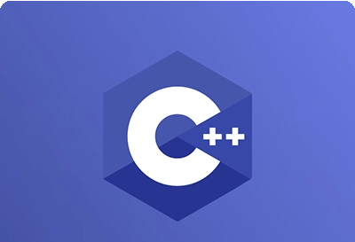

## C++

// C++ program to demonstrate working of a Pointers #include <iostream>

**using namespace** std;

**class** Rectangle {

**private**:

**int** length;

**int** breadth;

};

**void** fun()

{

// By taking a pointer p and

// dynamically creating object

// of class rectangle Rectangle* p = **new** Rectangle();

}

**int** main()

{

// Infinite Loop

**while** (1) {

fun();

}

}

Output:

Memory limit exceeded

Explanation: In function *fun*, it creates a pointer that is pointing to the *Rectangle* object. The object *Rectangle* contains two integers, *length,* and *breadth*. When the function *fun* ends, p will be destroyed as it is a local variable. But, the memory it consumed won’t be deallocated because we forgot to use *delete p;* at the end of the function. That means the memory won’t be free to be used by other resources. But, we don’t need the variable anymore, we need the memory.

In function *main*, *fun* is called in an infinite loop. That means it’ll keep creating *p*. It’ll allocate more and more memory but won’t free them as we didn’t deallocate it. The memory that’s wasted can’t be used again. Which is a memory leak. The entire *heap* memory may become useless for this reason.

# Smart Pointers

As we’ve known unconsciously not deallocating a pointer causes a memory leak that may lead to a crash of the program. Languages Java, C# has *Garbage Collection Mechanisms* to smartly deallocate unused memory to be used again. The programmer doesn’t have to worry about any memory leaks. C++ comes up with its own mechanism that’s *Smart Pointer*. When the object is destroyed it frees the memory as well. So, we don’t need to delete it as Smart Pointer does will handle it.

A *Smart Pointer* is a wrapper class over a pointer with an operator like * and -> overloaded. The objects of the smart pointer class look like normal pointers. But, unlike *Normal Pointers* it can deallocate and free destroyed object memory.

The idea is to take a class with a pointer, [destructor,](https://www.geeksforgeeks.org/destructors-c/) and [overloaded operators](https://www.geeksforgeeks.org/operator-overloading-c/) like * and -

>. Since the destructor is automatically called when an object goes out of scope, the dynamically allocated memory would automatically be deleted (or the reference count can be decremented).

*Example:*

## C++

// C++ program to demonstrate the working of Smart Pointer #include <iostream>

**using namespace** std;

**class** SmartPtr {

**int**\* ptr; // Actual pointer

**public**:

// Constructor

**explicit** SmartPtr(**int**\* p = NULL) { ptr = p; }

// Destructor

~SmartPtr() { **delete** (ptr); }

// Overloading dereferencing operator

**int**& operator*() { **return** *ptr; }

};

**int** main()

{

SmartPtr ptr(**new int**());

*ptr = 20; cout << *ptr;

// We don't need to call delete ptr: when the object

// ptr goes out of scope, the destructor for it is automatically

// called and destructor does delete ptr.

**return** 0;

}

Output

20

### Difference Between Pointers and Smart Pointers

|  |  |
| --- | --- |
| Pointer | Smart Pointer |
| A pointer is a variable that maintains a memory address as well as data type information about that memory location. A pointer is a variable that points to something in memory. | It’s a pointer-wrapping stack-allocated object. Smart pointers, in plain terms, are classes that wrap a pointer, or scoped pointers. |
| It is not destroyed in any form when it goes out of its scope | It destroys itself when it goes out of its scope |
| Pointers are not so efficient as they don’t support any other feature. | Smart pointers are more efficient as they have an additional feature of memory management. |
| They are very labor-centric/manual. | They are automatic/pre-programmed in nature. |

*Note: This only works for int. So, we’ll have to create Smart Pointer for every object? No, there’s a solution,* [*Template*](https://www.geeksforgeeks.org/templates-cpp/)*. In the code below as you can see T can be of any type.*

Example:

## C++

// C++ program to demonstrate the working of Template and

// overcome the issues which we are having with pointers #include <iostream>

**using namespace** std;

// A generic smart pointer class

**template** <**class** T> **class** SmartPtr {

T* ptr; // Actual pointer

**public**:

// Constructor

**explicit** SmartPtr(T* p = NULL) { ptr = p; }

// Destructor

~SmartPtr() { **delete** (ptr); }

// Overloading dereferencing operator T& operator*() { **return** *ptr; }

// Overloading arrow operator so that

// members of T can be accessed

// like a pointer (useful if T represents

// a class or struct or union type) T* operator->() { **return** ptr; }

};

**int** main()

{

SmartPtr<**int**> ptr(**new int**());

*ptr = 20; cout << *ptr; **return** 0;

}

Output:

20

*Note: Smart pointers are also useful in the management of resources, such as file handles or network sockets.*

# Types of Smart Pointers

C++ libraries provide implementations of smart pointers in the following types:

auto_ptr unique_ptr shared_ptr weak_ptr

# auto_ptr

Using auto_ptr, you can manage objects obtained from new expressions and delete them when auto_ptr itself is destroyed. When an object is described through auto_ptr it stores a pointer to a single allocated object.

*Note: This class template is deprecated as of C++11. unique_ptr is a new facility with a similar functionality, but with improved security.*

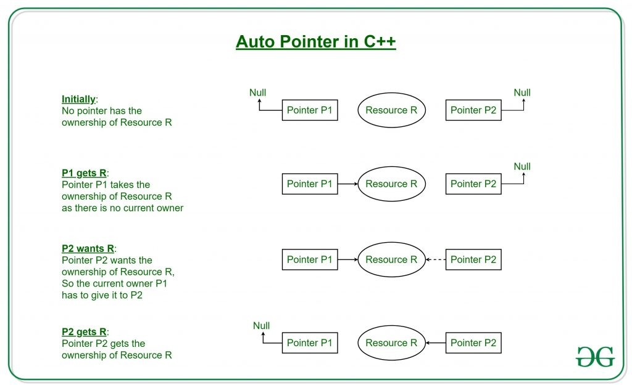

# unique_ptr

*unique_ptr* stores one pointer only. We can assign a different object by removing the current object from the pointer.

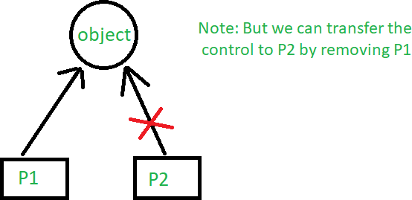

Example:

## C++

// C++ program to demonstrate the working of unique_ptr

// Here we are showing the unique_pointer is pointing to P1.

// But, then we remove P1 and assign P2 so the pointer now

// points to P2.

#include <iostream>

**using namespace** std;

// Dynamic Memory management library #include <memory>

**class** Rectangle { **int** length; **int** breadth;

**public**:

Rectangle(**int** l, **int** b)

{

length = l; breadth = b;

}

**int** area() { **return** length * breadth; }

};

**int** main()

{

// --\/ Smart Pointer

unique_ptr<Rectangle> P1(**new** Rectangle(10, 5)); cout << P1->area() << endl; // This'll print 50

// unique_ptr<Rectangle> P2(P1);

unique_ptr<Rectangle> P2; P2 = move(P1);

// This'll print 50

cout << P2->area() << endl;

// cout<<P1->area()<<endl;

**return** 0;

}

Output

50

50

# shared_ptr

By using *shared_ptr* more than one pointer can point to this one object at a time and it’ll maintain a Reference Counter using the *use_count()* method.

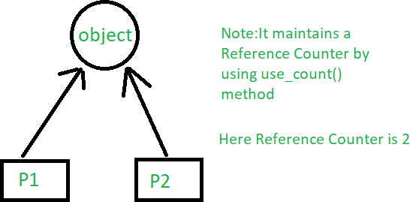

## C++

// C++ program to demonstrate the working of shared_ptr

// Here both smart pointer P1 and P2 are pointing to the

// object Addition to which they both maintain a reference

// of the object #include <iostream> **using namespace** std;

// Dynamic Memory management library

#include <memory>

**class** Rectangle {

**int** length;

**int** breadth;

**public**:

Rectangle(**int** l, **int** b)

{

length = l; breadth = b;

}

**int** area() { **return** length * breadth; }

};

**int** main()

{

//---\/ Smart Pointer

shared_ptr<Rectangle> P1(**new** Rectangle(10, 5));

// This'll print 50

cout << P1->area() << endl;

shared_ptr<Rectangle> P2; P2 = P1;

// This'll print 50

cout << P2->area() << endl;

// This'll now not give an error, cout << P1->area() << endl;

// This'll also print 50 now

// This'll print 2 as Reference Counter is 2 cout << P1.use_count() << endl;

**return** 0;

}

Output

50

50

50

2

# weak_ptr

Weak_ptr is a smart pointer that holds a non-owning reference to an object. It’s much more similar to shared_ptr except it’ll not maintain a Reference Counter. In this case, a pointer will not have a stronghold on the object. The reason is if suppose pointers are holding the object and requesting for other objects then they may form a Deadlock.

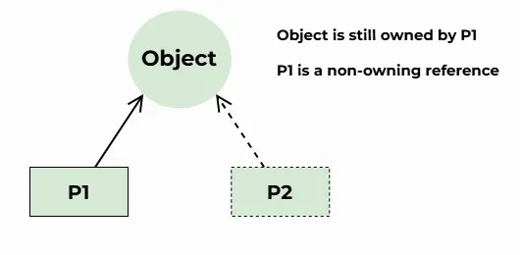

## C++

// C++ program to demonstrate the working of weak_ptr

// Here both smart pointer P1 and P2 are pointing to the

// object Addition to which they both does not maintain

// a reference of the object

#include <iostream>

#include <memory>

using namespace std;

// Dynamic Memory management library #include <memory>

class Rectangle { int length; int breadth;

public:

Rectangle(int l, int b)

{

length = l; breadth = b;

}

int area() { return length * breadth; }

};

int main()

{

//---\/ Smart Pointer

shared_ptr<Rectangle> P1(new Rectangle(10, 5));

// This'll print 50

cout << P1->area() << endl;

weak_ptr<Rectangle> P2 = P1;

// P2 = P1;

// This'll print 50

if (auto temp = P2.lock()) {

cout << "Area from P2 (locked weak_ptr): " << temp->area() << endl;

} else {

cout << "P2 is expired." << endl;

}

// This'll now not give an error,

cout << P1->area() << endl;

// This'll also print 50 now

// This'll print 2 as Reference Counter is 2

cout << P1.use_count() << endl;

return 0;

}

Output

50

50

50

1

[C++ libraries provide implementations of smart pointers in the form of auto_ptr, unique_ptr, shared_ptr, and weak_ptr](https://www.geeksforgeeks.org/auto_ptr-unique_ptr-shared_ptr-weak_ptr-in-cpp/)